Method: Blind Dado (with qualified tenon)



**Face Frame (3/4 thick)**

Stiles 2”

Bottom Rail 2”

Top Rail Base 2”

Top Rail Wall / Tall 3”

Return End Stile Base 3”

Return End Stile Wall 2”

Extended End Stile Base 3 ¾”

Extended End Stile Wall 2 ¾”

**To modify Frame sizes:**

Click Libraries

Select FACE FRAME

Click the Construction Button

Select the FACE Category

**To modify Ret/Ext End Stiles**

Click Libraries

Select FACE FRAME

Click the Construction Button

Select the ENDS Category

**SCRIBE**

Finished End Scribe – ¼”

Unfinished End Scribe – ¼”

**To modify Scribe**

Click Libraries

Select FACE FRAME

Click the Construction Button

Select the CASE Category

**Material Templates**

www.mozaiksoftware.com

*Optimized for flat panel processing*

This construction method is for Face Frame and Frameless construction with hidden dados. Bottoms & Tops dado into the ends, partitions dado into the Top & Bottom. Fixed Shelves dado into the verticals. All tenons are machined to a qualified thickness. This ensures a perfect fit (even if the material thickness varies slightly from sheet to sheet).

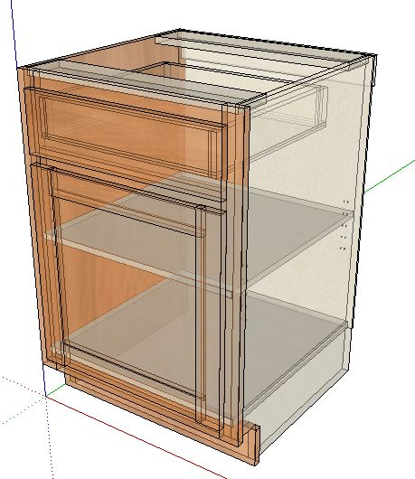

**Part Operations.**

Case Parts

Dado Depths.

Bottom / Top into End Panels ¼”

Fixed Shelves ¼”

Partitions into Bottom/Top ¼”

Back into End panels ¼”

Adjustable Shelves.

3/16” clearance

Face Frames

Butt Joint construction (Pocket Screws-recommended)

**Machining Specifications**.

Nested Based Router Setup.

Tool #1 3/8 compression spiral (Outline tool)

Tool #2 3/8 down shear bit (dados/pockets)

Tool #3 1/4 down shear bit (back dados)

Tool #4 1/2 down shear bit (3/4 dados/pockets)

Drills 5mm

(If no boring block, place a 5mm bit into Tool #5)

Machines with no Tool Changer.

Primary Tool 1/4 compression spiral.

(Adjustable shelf holes will be ¼”.)

**Assembly Details.**

Page 2 www.mozaiksoftware.com